**DBS-LAB-2 SELECT AND WHERE CLAUSES OF SQL**

CLASS_ID->[BCSE302P_VL2023240101053](https://moovit.vit.ac.in/course/view.php?id=13241#section-2)

NAME ->ADITYA SINHA

REG.NO->21BKT0022

CREATE A TABLE FOR STORING THE FOLLOWING DETAILS OF EMPLOYEE

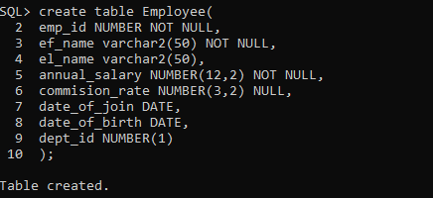

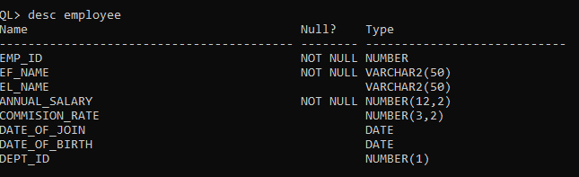

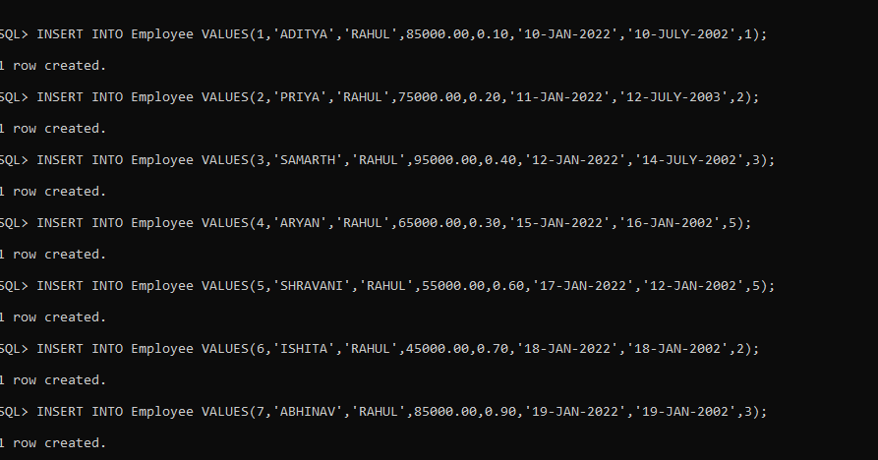

1. 1.Get the records of all sales EMPLOYEE whose annual salary is equal or greater than Rs.50K

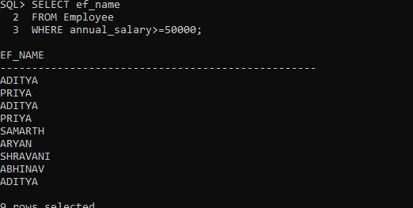

2.List all employee whose have a commission rate above 0.12

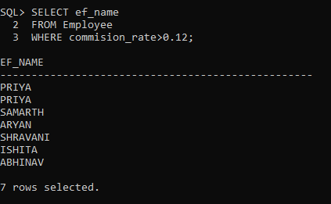

3.List the sale employee whose commission earnings in 2021 were greater than their annual salary:

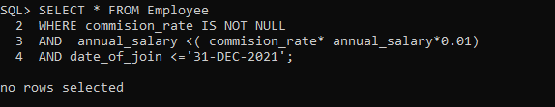

4.List all sales employee whose commission rate is between 0.10 and 0.14, you can use the following query

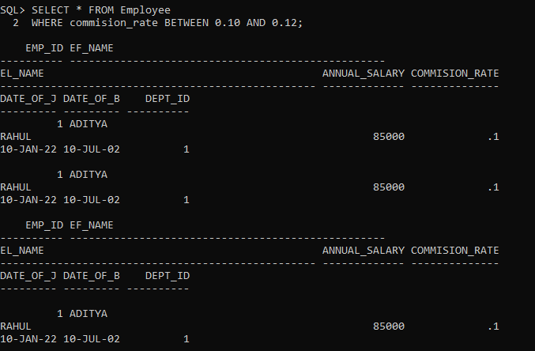

5.List sales employee whose last name (when sorted alphabetically) is before ‘Kumar’

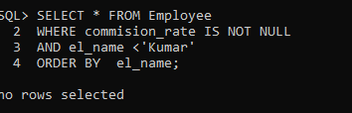

5.List all sales employee whose last name starts with 'C'



6.Retrieve all records that have NULL in the commission column

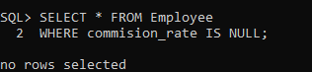

7.List the name of the employee who are working in dept 1 or 2 or 3 (use IN operator)

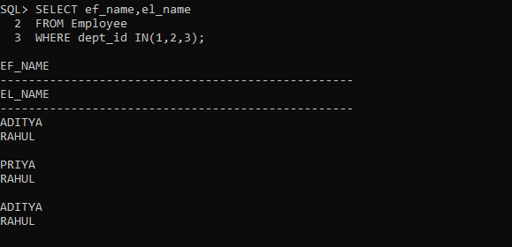

8.List all employee that work in dept 5 and have salaries equal to or greater than Rs.50K

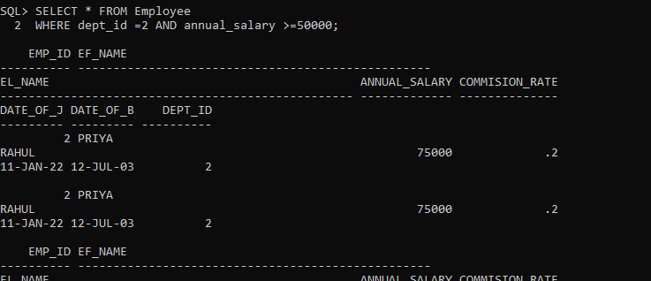

9.etrieve all records where the last name is either ‘Kumar’ or ‘Raj'

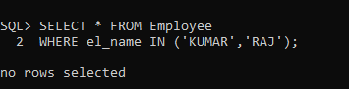

10.Get information on all employee except the ones who work in dept 2

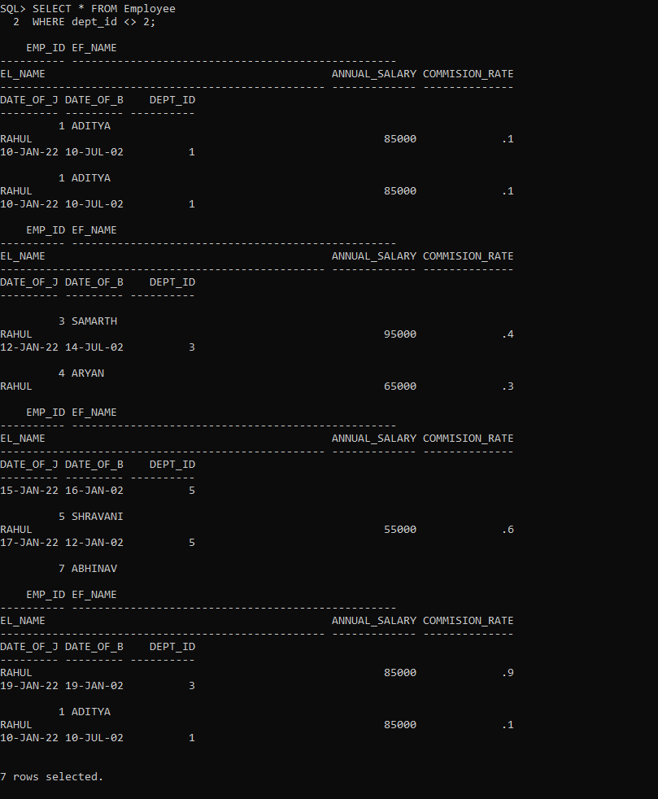

11.Retrieve all records where an employee’s last name is either ‘Kumar’ or ‘Raj’, their commission earnings

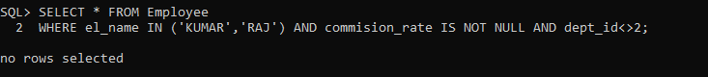

12.Find out the experience of all the employee in terms of number of years

